

Expensify

USER GUIDE

TABLE OF CONTENTS

Expensify 1
Access 1
Note 3
Set Up 6
Mileage Reimbursement 11
Start Trip 11
Stop Trip 12
Code Trip 13
Single Practice 13
Multiple Practices 16
Expense Report 22
Expenses With Milage 22
Expenses ONLY * No Mileage * 28
Add Expenses 28
Code expenses 30
single Practice 30
Multiple Practices 34

Expensify

Expensify is an expense management system for business expenses. It simplifies the process of expense tracking and reimbursement as well as management of corporate cards. Set up and use can be completed online.

Access

- Sign In
  - You will receive the invite to join via email.
- Set Up
  - Online
    - Click the link provided.
- The dashboard will open.
    - Things for them to choose?
      - Should I update you when receipts/reports need attention or colleagues have questions?
        - Click Yes alert me when needed.
      - Do you want to use your location to track mileage and improve currency recognition of your receipts?
        - Click Enable Location
      - Ready to SmartScan your first receipt?
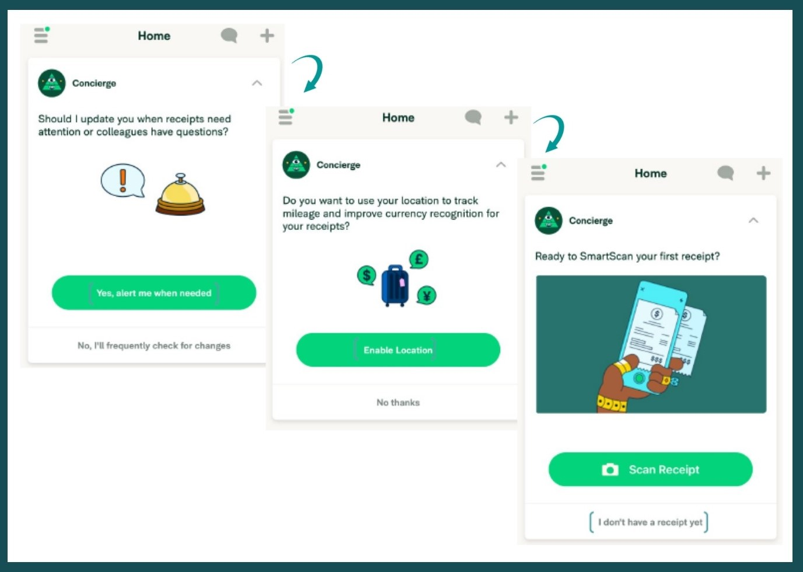

Mileage Reimbursement

Mileage reimbursement is what you are paid for business related use of your personal vehicle. The reimbursement rate is based on the current year’s IRS standard rate of reimbursement. Mileage reimbursements must be recorded and requested in real time via the app ONLY.

You will need to enable location in Expensify if you have not done so already. If the trip is for multiple locations, the cost for the trip must be split for each location accordingly.

The processes are outlined below.

- Access the Expensify Application (via mobile)
  - The dashboard will open.

Start Trip

- Click the 3 lines in the top left corner.
  - Select Expenses
    - Click the ( + ) arrow in the top right corner.
      - Select Start GPS

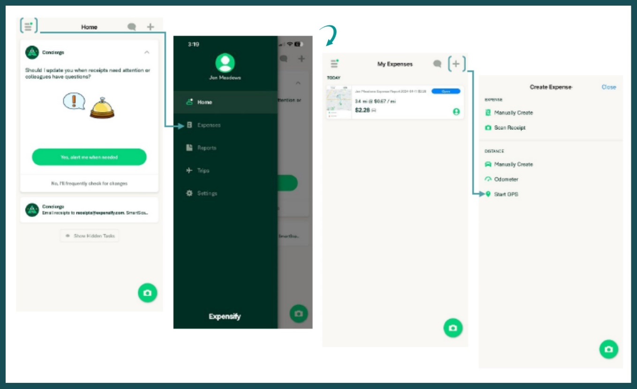
        - Click Start

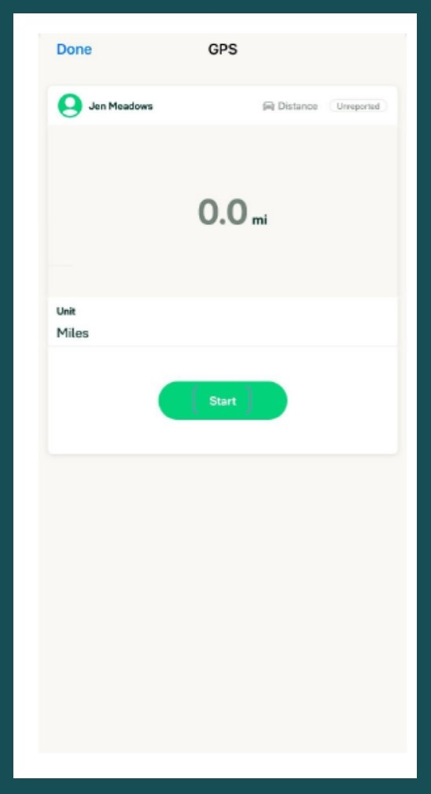
          - Leave the application running while you drive.

Stop Trip

- Click Stop
  - Stop GPS recording? YES
    - Select Use
      - Click Save
        - The expense will be uploaded for further processing.
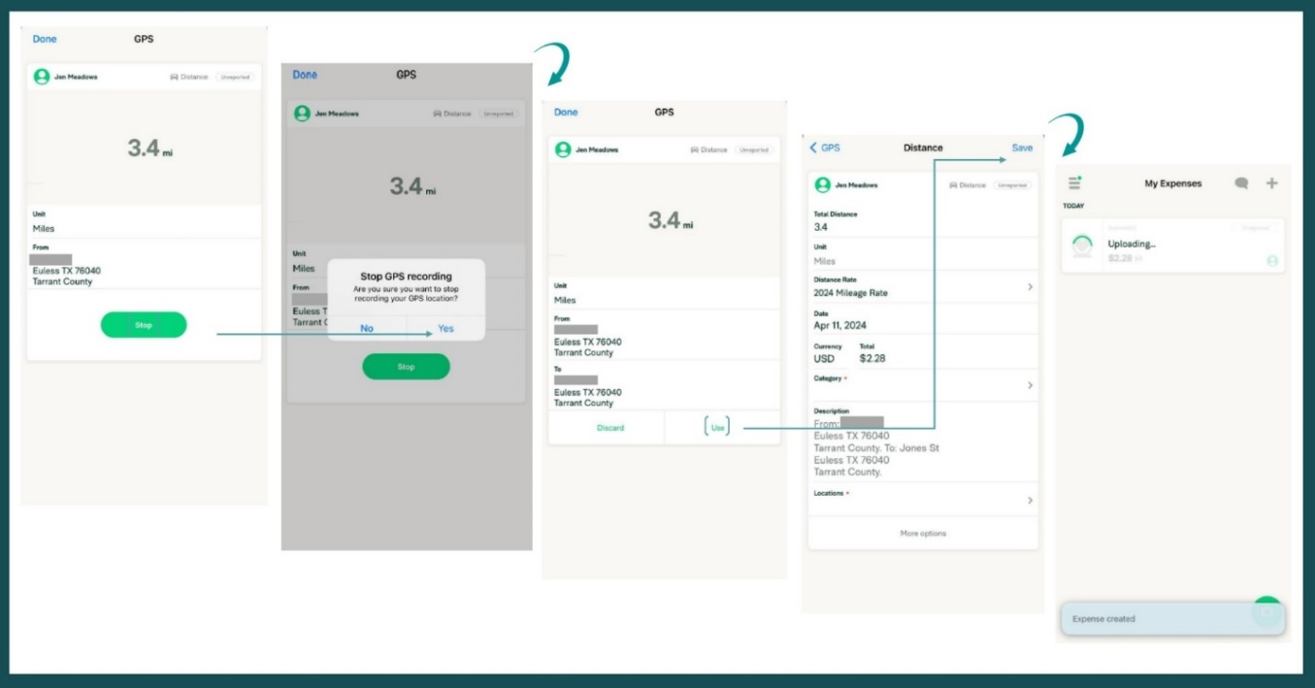

Code Trip

Code your trip according to business purpose
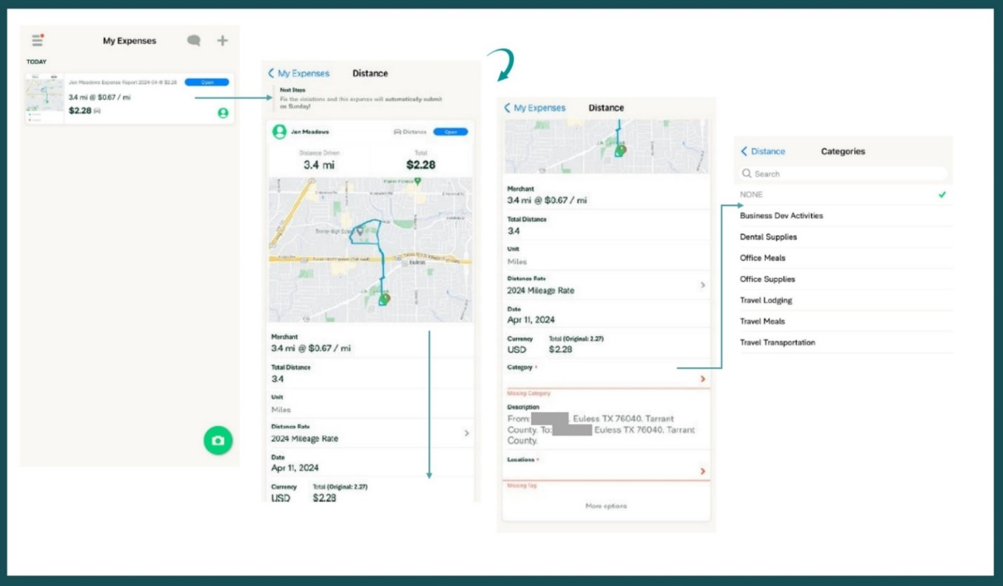
  - Click Save
- To check expense to ensure it has been completed

Expense Report

The expense reimbursement process allows us to reimburse you for any out-of-pocket expenses you incur for business-related activities. The reimbursement rate is dollar for dollar; however, you MUST submit a receipt in order to be reimbursed. If the expense is for multiple practices, the cost must be split and coded for each practice accordingly.

The processes are outlined below.

- Access Expensify
  - The dashboard will open.

Expenses With Milage

Mileage and expenses completed concurrently can be submitted together, in fact it is recommended to do so. Once you have completed the trip (in real time) you may add any expenses to the same report.

- Click the 3 lines in the top left corner.
  - Select Reports
    - Locate the mileage expense (trip) you have just completed.
      - Click on the report to open.
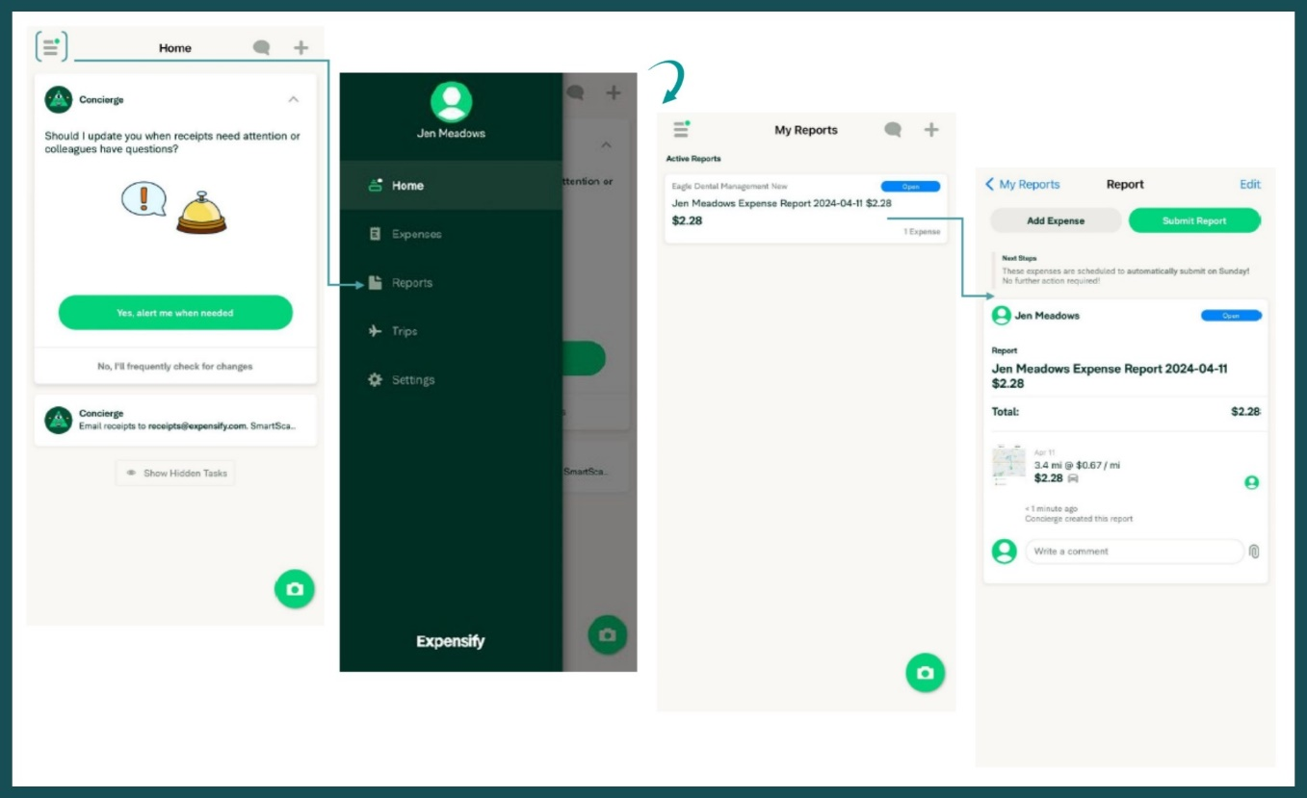
        - Select Add Expense
          - Click Create Expense
            - Select Scan Receipt
  - Expensify would like access to camera: Allow.

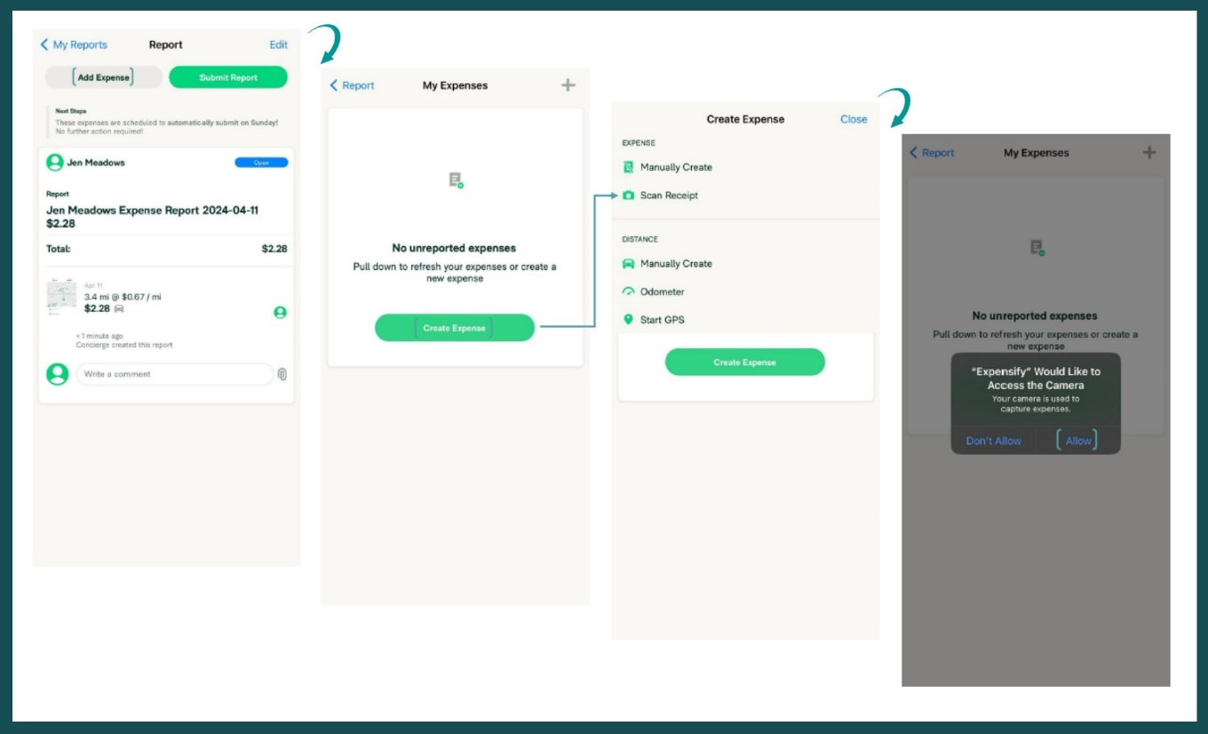
    - Take a photo of the entire receipt.
      - See SmartScanning Note below receipt.
        - Were working on extracting the details of this receipt. Check back in a short while.
          - Click Save
            - Your receipt has been uploaded and is being processed.
              - You will receive an alert when the receipt has been processed.
                - If you do not have alerts enabled, you will have to check back to ensure the receipt has been processed.
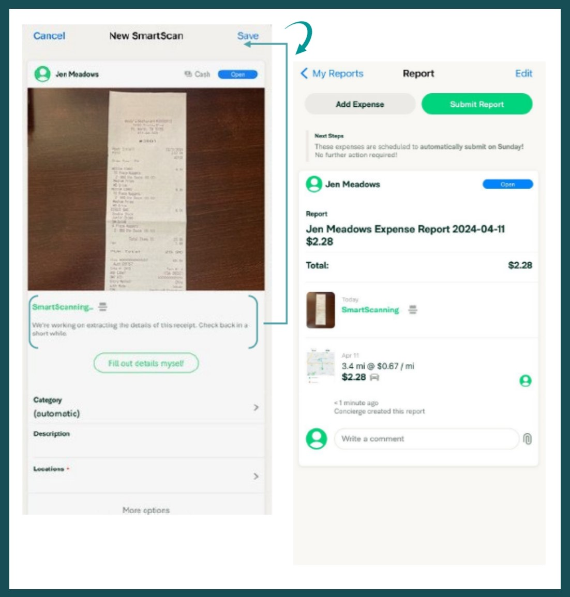
- Access alerts or click in the expense to open (If you click in the expense, see Next Steps)
  - You have violations blocking $x.xx of expenses from being submitted.
    - Click Fix Violations
      - Scroll down the screen to the highlighted items.
        - Click the arrow on the right of Category.
          - Select the category that applies to your expense.
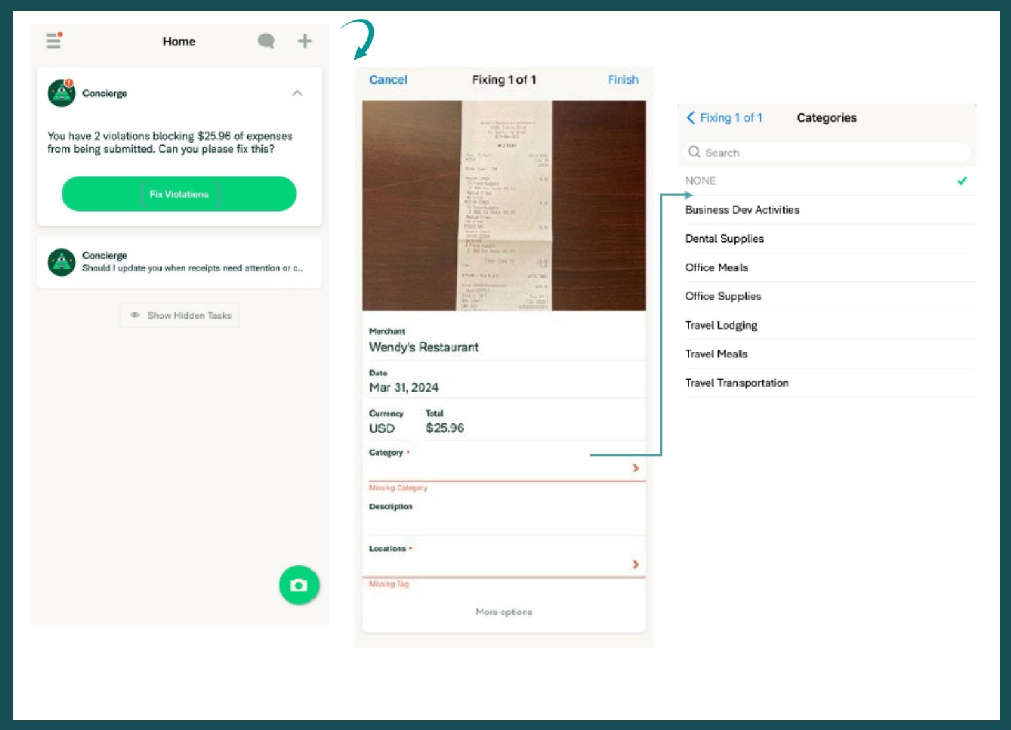
        - Click the arrow on the right of Locations.
          - Select the location that applies to your expense.
            - Click Finish

- Check alerts for additional violations.
  - Descriptions are required.
    - Click Fix Violations
      - Scroll down the screen to the highlighted items.
        - Click the arrow on the right of Description.
          - Add description / individuals.
            - Short descriptions and / or initials are acceptable.
              - Click finish.
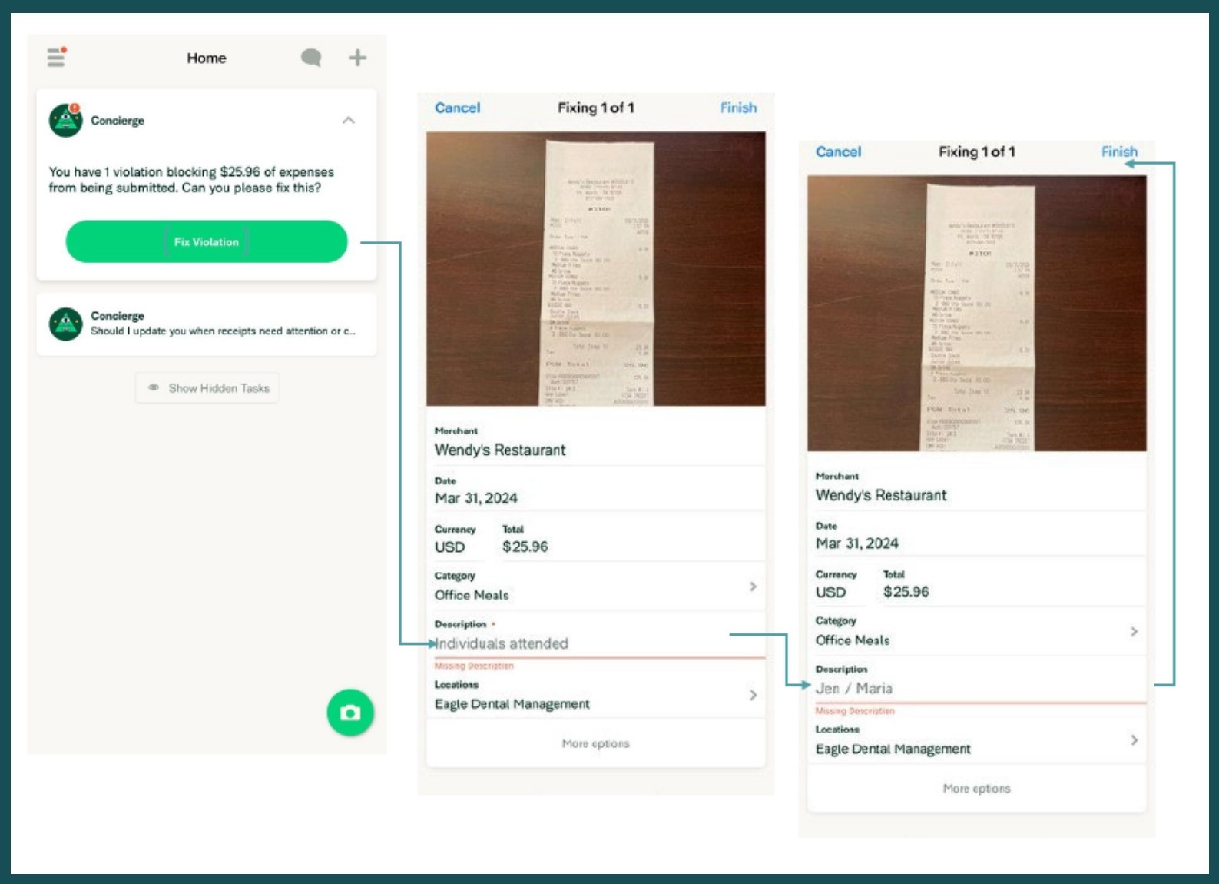
- To check the expense to ensure it has been completed.
  - Click in the expense to open.
    - See Next Steps
      - If there are any additional notes / violations
        - Follow the instructions.
      - If note alerts / notes
        - These expenses are scheduled to automatically submit on Sunday, no further action is required.
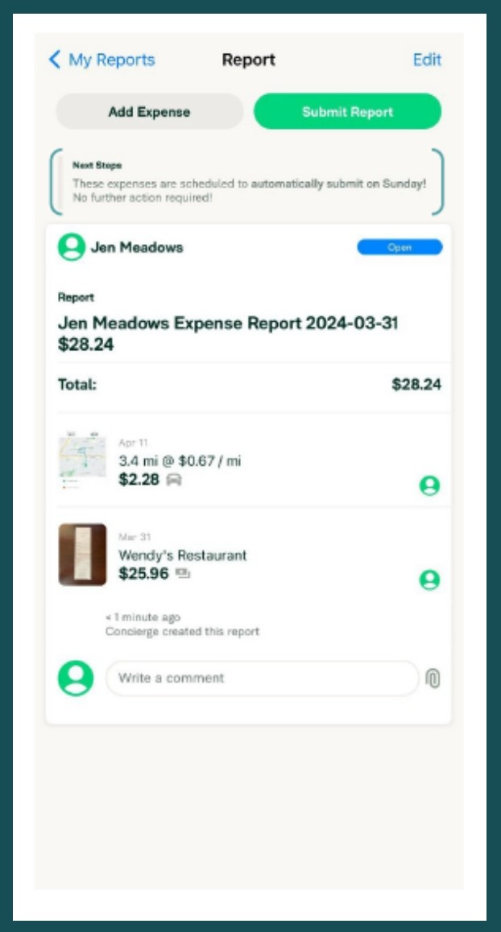

Expenses ONLY * No Mileage *

Expenses without milage need to be added by Friday before you leave for the day each week that you have expenses.

Add Expenses

- Click the 3 lines in the top left corner.
  - Select Expenses
    - Click the ( + ) arrow in the top right corner.
      - Select Scan Receipt

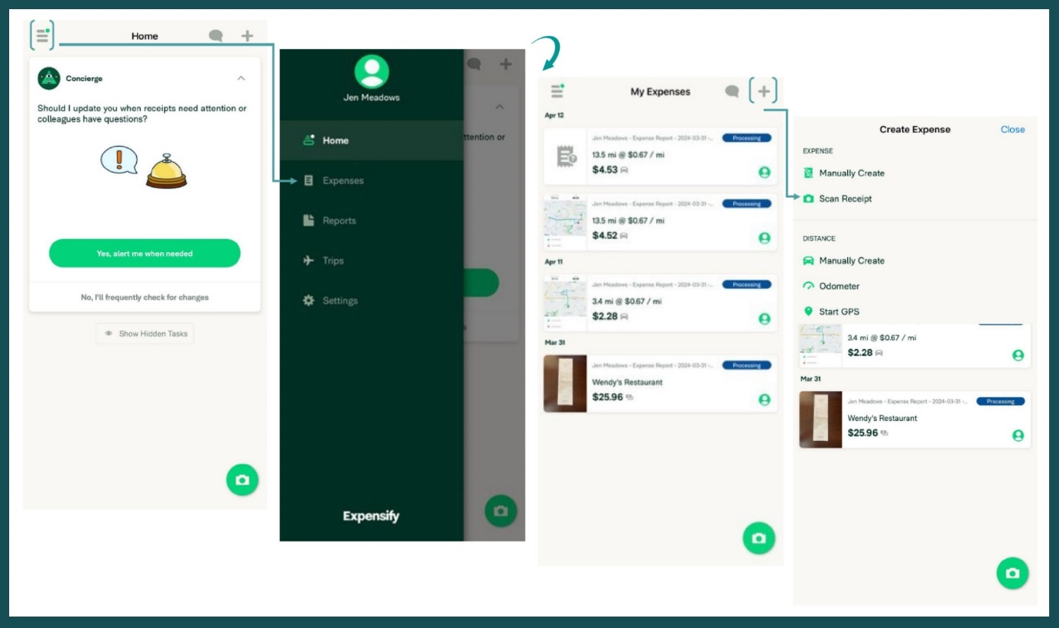
        - Take a photo of the entire receipt.
          - See SmartScanning note below receipt.
            - Were working on extracting the details of this receipt. Check back in a short while.
              - Click Save
      - Your receipt has been uploaded and is being processed.
        - You will receive an alert when the receipt has been processed.
          - If you do not have alerts enabled, you will have to check back to ensure the receipt has been processed.
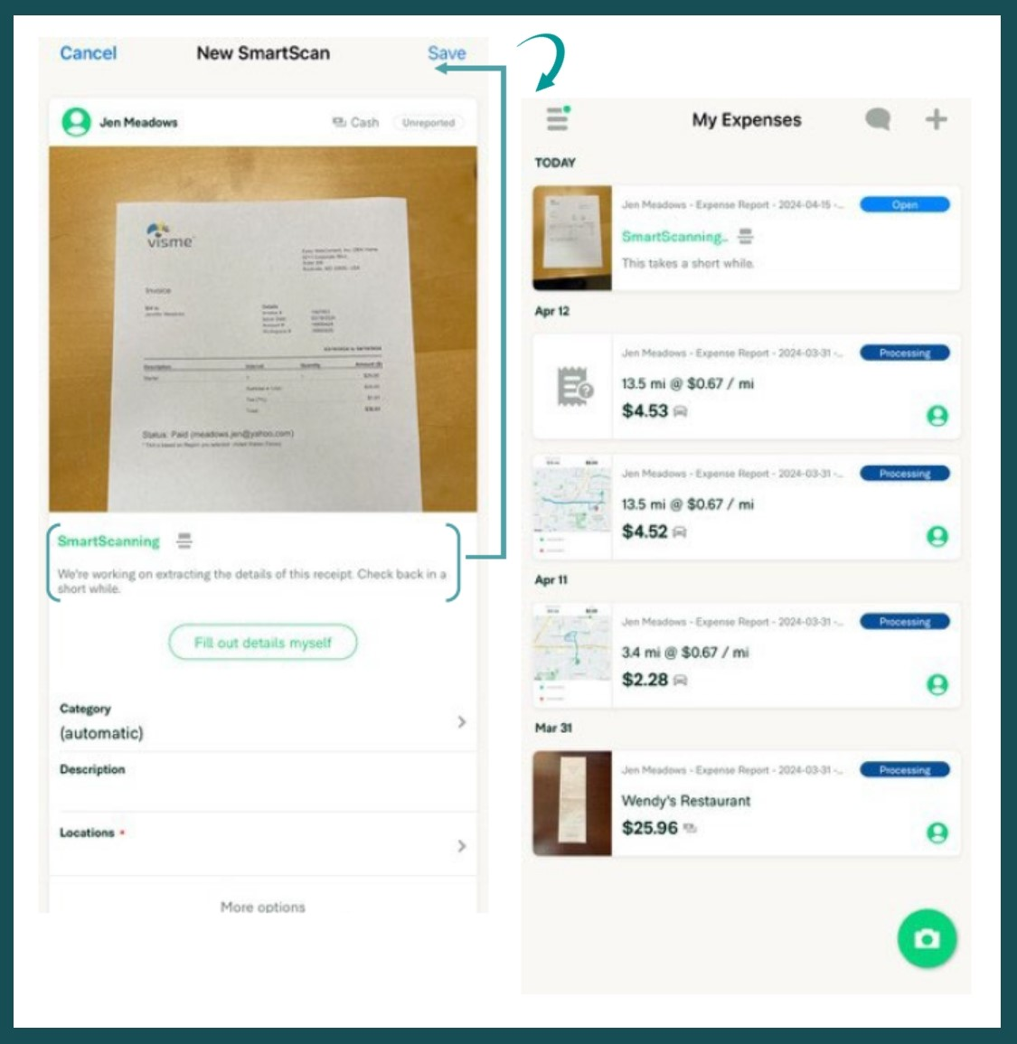

Code expenses

- Access alerts or click in the expense to open. (if you click in the expense, see Next Steps)
  - You have violations blocking $x.xx of expenses from being submitted.
    - Click Fix Violations
      - Scroll down the screen to the highlighted items.
        - Click the arrow to the right of the category.
          - Select the category that applies to your expense.
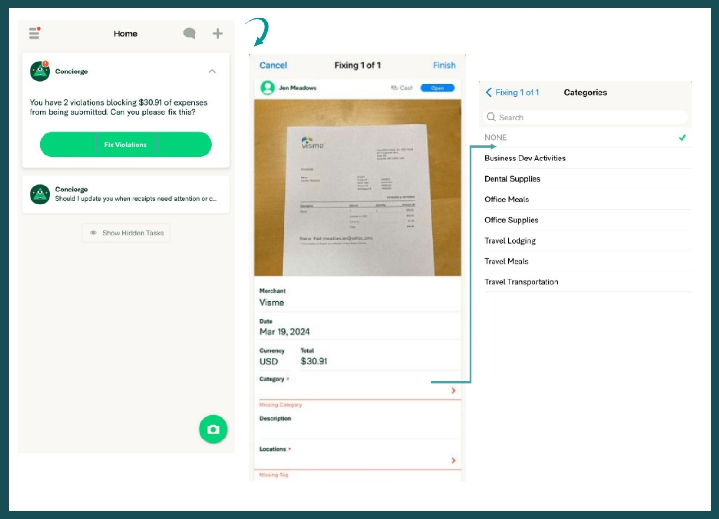
        - Click the arrow to the right of locations.
          - Select the location that applies to your expense.
            - Click Finish

- Check alerts for additional violations.
  - Descriptions are required.
    - Click Fix Violations
      - Scroll down the screen to the highlighted items.
        - Click the arrow to the right of the description.
          - Add description / individuals.
            - Short descriptions and / or initials are acceptable.
              - Click Finish

- To check the expense to ensure it has been completed.
  - Click in the expense to open.
    - See Next Steps
      - If there are any additional notes / violations
        - Follow the instructions.
      - If no alerts / notes
        - This expense is scheduled to automatically submit on Sunday, no further actions is required.
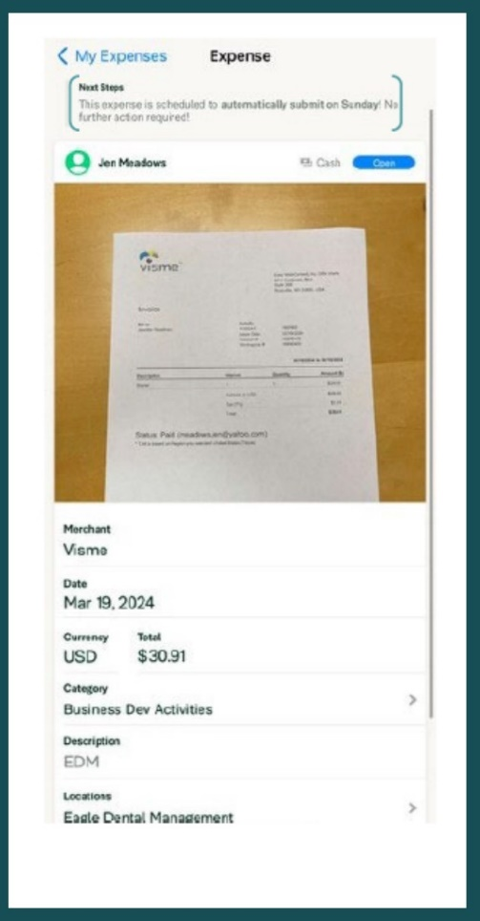

- To check the expense to ensure it has been completed.
  - Click in the expense to open.
    - See Next Steps
      - If there are any additional notes / violations
        - Follow the instructions.
      - If no alerts / notes
        - This expense is scheduled to automatically submit on Sunday, no further action is required.

